Dylan Thomas Timeline
(Reading exercise)

1914  October 27 | October 27th: Dylan Marlais Thomas born at 5 Cwmdonkin Drive, Uplands, Swansea.  Older sister: Nancy Marles Thomas.  Parents: David John and Florrie Thomas (Both from Carmarthenshire, D.J.Thomas was senior English Master at Swansea Grammar School). | 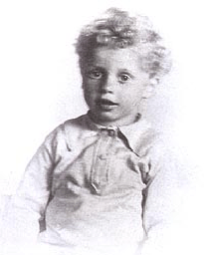
1925 | Primary school: Mrs Hole's 'Dame School' in Mirador Crescent.  Dylan entered Swansea Grammar School.
1926 | First prize for running the mile at Swansea Grammar School.  He did not excel in his academic work but was a good actor and very good at creative writing in English.
1931 | Dylan became a junior reporter on the South Wales Daily Post. (This later became the South Wales Evening Post). | 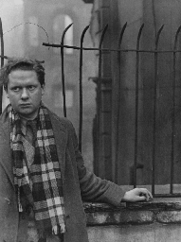
1932 | Dylan joined Swansea Little Theatre Company, based in Mumbles.  He acted in a number of productions.  December: Dylan left South Wales Daily Post to work full time on his poetry.  He became friends with a group of talented young Swansea men who met in the KARDOMAH café.  The Kardomah gang were: Vernon Watkins (poet), Daniel Jones (composer), Alfred Janes (artist), John Prichard, Tom Warner, Charlie Fisher, Mervyn Levy (artist) and Ronald Cour (artist). | 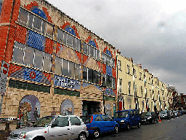

1934 | November: Dylan moved to London.  December: His first book of poems appeared 18 poems. | 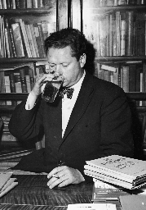
1937 | July 11th: Dylan and Caitlin Macnamara married in Penzance, Cornwall.
1938 | May: Dylan and Caitlin moved to Laugharne to live. | 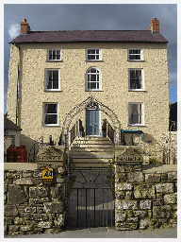
1939 | 30 January: Their first child was born. Llewelyn Edwouard Thomas. | 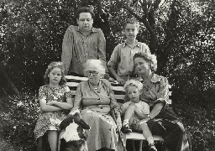
1940 | Dylan and Caitlin moved to London where Dylan wrote propaganda films about the war.
1943 | 3 March: Aeronwy Bryn Thomas, Dylan and Caitlin's second child, was born in London. | 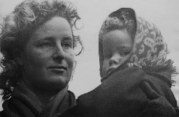
1944 | September: Dylan, Caitlin and children moved to New Quay, Ceredigion.  Dylan started to experiment with characters for one of his most famous works Under Milk Wood.
1949 | May: Dylan, Caitlin and family moved to the Boat House in Laugharne and his parents to a house opposite Brown's Hotel in Laugharne.  July 24th: Colm Garan Hart Thomas was born  Dylan wrote in a shed called 'The Writing Shed'. The view of the sea and the peace and quiet would help him to write. | 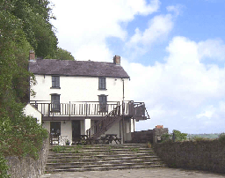

1950 | February 20th: Dylan flew to New York to begin his first tour of the United States.  June 1st: Dylan returned to Britain on board the Queen Elizabeth having given at least 39 readings and lectures all over the USA and Canada. | 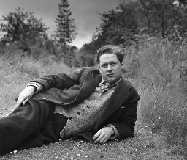
1953 | April 21st: Dylan left for New York to begin his third American tour.  June 3rd: Dylan returned to London.  October 19th: Dylan left for New York to begin his fourth and final American tour.  October 29th: Dylan's last ever public engagement - a lunchtime reading at the City College of New York.  November 5th: Dylan collapsed at the Chelsea Hotel, New York.  November 9th: Dylan died at St Vincent's Hospital and Caitlin brought his body back to Laugharne.  November 25th: Dylan's funeral at Laugharne. | 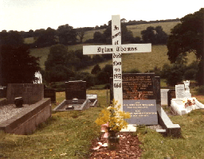
1954 | January 25th: First BBC broadcast of Under Milk Wood - with Richard Burton starring as First Voice. | 